Requirements Specification for Canvas Centralized Communication System

Prepared by ​*Group AE3*

*9 March 2018*

Ju An Oh | Min Yang | Sean Martin | Minsu Gim

Table of Contents

**1. Executive Summary** **3**

**2. Introduction** **4**

2.1 Purpose 4

2.2 Scope 4

2.3 Assumptions and Dependencies 6

2.4 Current State 6

**3. System Description** **8**

3.1 System Overview 8

3.2 Key Users 10

3.3 Design and Implementation Constraints 11

**4. Process Flow** **12**

**5. User Interfaces** **13**

**6. System Requirements** **14**

6.1 Functional Requirements 14

6.2 Use Cases 15

**7. External Interface Requirements** **26**

**8. Nonfunctional Requirements** **27**

**9. Operating Environment** **28**

**10. Appendix** **29**

**1. Executive Summary**

This report details a proposal to address the communication issues that the iSchool faces as a result of the current iteration of Canvas. A core goal of Canvas is to provide an environment that facilitates collaboration, and Canvas has implemented features in the past to that end. However, this goal has yet to be realized, and Canvas collaboration tools are so lacking as to cede the space to third party applications. This failure warrants a new direction in Canvas collaboration and communication features. Inspired by interviews and personal experiences with the learning management system, this project will implement a communication system on Canvas that will solve its current communication issues that have detracted from the function of a learning management system.

This proposal represents a centralization of disparate communication elements into a one-stop center for collaboration. This includes incorporating the most important features that users have cited in the third-party communication tools that they use in lieu of Canvas. This will modernize the Canvas collaboration experience, and eliminate the need for users to turn to other applications. This document will describe the current state of communication processes on Canvas and outline the resulting issues that arise in the iSchool community as a product of those processes. Research is provided to support the validity of this solution to the issues.

Subsequently, the proposed system will be described in detail to prepare for implementation. This includes a details about how this new system will be used, including expected use cases and the system’s process flow. outlined in detailed in order to justify the utility of a centralized communication system. The project’s requirements, environment and limitations are described in order to outline the metrics of a successful implementation and the potential benefits and drawbacks thereof.

**2. Introduction**

**2.1 Purpose**

This project will overhaul the communication systems in Canvas. With its current disparate system of communicating with other course members and instructors, it is necessary for a new communication system to be implemented that will enable efficient and organized communication. This will greatly increase the productivity of students and instructors alike since they will not need to switch in and out of different communication platforms.

This proposal is to avoid navigation between various platform by implementing and centralizing communication and collaboration tools on Canvas. This will reduce this kind of redundancy and inefficiency by centralizing communication features on Canvas, so students and instructors can communicate on a single Canvas page, thereby reducing Canvas navigation and streamlining the communication process.

**2.2 Scope**

The scope for this project is the includes parts of the Canvas website that are meant to facilitate communication. Specifically, the ‘Inbox’ and ‘Discussion’ sections of Canvas are affected. Other features of Canvas such as file management, assignments, feedback, and grading will not be considered in this project. The user research showed a great interest and need for a better system of classroom collaboration.

**Scope of Initial Release**

The initial release will include a modernized messaging system and will merge the ‘Group’ and ‘Inbox’ tabs currently on Canvas. Course channels will be created automatically once the course itself is created and students automatically populate the course. There will be a course discussion board channel that will have a layout similar to Piazza so that instructor answers will be prioritized and questions can be categorized with moderated tags. Every student in the course will be automatically added to this channel.

If the instructor chooses to make groups, these groups will then have their own channels created for them automatically, with the members being added to their respective channels. Students will also be able to create groups in which direct messaging will be an option, as user research indicates a live chat function is desired.

**Scope of Subsequent Releases**

Subsequent releases will focus on refinements, compatibility, and transitioning to the new system. Upon implementation, new user research will be conducted to gather feedback on the new system. Subsequent iterations of the new system will have features removed, added, or altered to best match user needs indicated by this research. The following are some additional promising concepts that are awaiting user feedback :

* Online and offline indicators for channel and course members.
* Emoji support.
* The ability to ‘like’ messages as responses to provide feedback to message authors.
* Private/public options for channels.
* Markdown support for efficient descriptions and collaboration.

**Limitations and Exclusions**

The project will be limited to the basic and necessary features during launch. Stakeholders may anticipate features such as in-platform live collaboration on documents or video-chatting and be disappointed to find that they are not included upon launch.

The project is also constrained by a $1.5 million dollar budget and thus the most immediate concerns are the features that have been requested and identified through research. Successful launch and implementation will determine the furthering of our extended goals and addition of features.

**2.3 Assumptions and Dependencies**

It is assumed that the institutions and users are verified. The success of this project depends on development partners such as UX designers and back-end developers. Based on user research we assume that it’s okay to show the online/offline status of the users, but this may change upon launch. Since users indicate that they want to join their group chats automatically, we assume that we will need to automatically build group and course channels/chats as soon as these groups are formed. Lastly, software developers and UX designers must be capable of designing and implementing this communication system that we envision. Additionally, the project depends on these software developers and UX designers to comply with WGAC standards in order to make sure our application is accessible to all users.

**2.4 Current State**

The stakeholders in this project are iSchool instructors, students, faculty, Canvas management, and UW-IT. Currently, the instructors make their course page and have the choice to use the communication features available to them through Canvas. However, user research indicates that most users do not like to use Canvas ‘Inbox’ or ‘Discussion’ sections. groups that are made on Canvas also report deferring to other platforms to collaborate instead of using the page that is set up for them on Canvas.

Currently, the communication process consists of three major parts. 1.) Using the course page to read announcements, start discussions and download shared files by the instructor. 2.) Finding the ‘Group’ page where announcements, discussions and files can be found - essentially an entirely new Canvas website just for a group. And 3.) Using Canvas ‘Inbox’ for direct messaging and group messaging in a hybrid style between e-main and live-messaging.

Several issues arise from this setup. Navigation to the right place to communicate with a target audience is difficult and cumbersome. Due to this, users abandon Canvas, and report mainly use Slack or Facebook Messenger to collaborate and communicate with each other. And to do that, users need to exchange information, download applications or sign up for different services in order to start collaborating with each other. The result is that Canvas features are foregone and users prefer to be saddled with additional burdens rather than use the Canvas features that they find inadequate.

**3. System Description**

**3.1 System Overview**

This system will be a replacement of all communication that occurs on Canvas. The current existing system diagram indicates that there are duplicates in the system. An entire course page is separated from group pages that serve the same functions in disparate manners. It is also seen that the Canvas Inbox system is separate from the other systems of communication, resulting in communication that is disorganized and unintuitive.

The new system will completely replace the old, removing the ‘Announcements’ and ‘Discussion’ tabs as well as the ‘Inbox’ system. A new ‘Connect’ tab will be put into the global navigation bar on Canvas which will display the new centralized communication system. In this new system, group channels, direct messages, course announcements, and discussions are categorized by course. The messaging system will be modernized and displayed as live-chat style, increasing the efficiency and clarity of communication between users.

Existing system diagram:

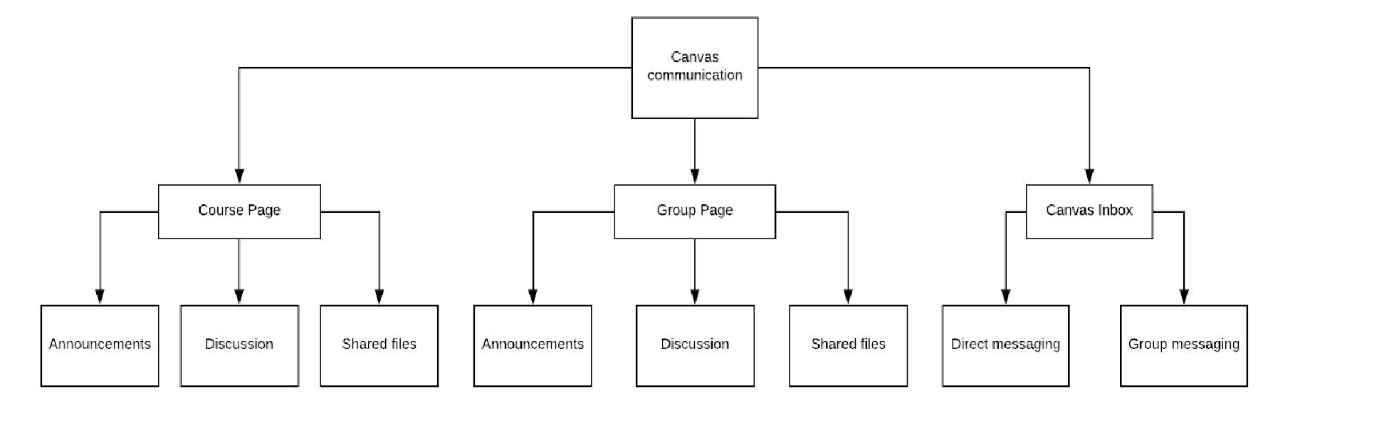

Proposed system diagram:

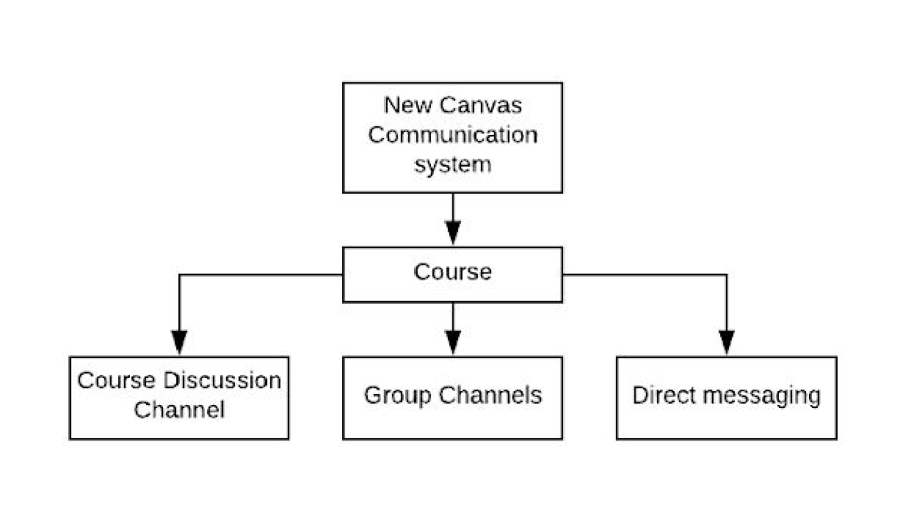

External interface of group channel and communication page

